**Lab 3 HTML(01/26/2024)**

Screen shot1 of repo on VS Code

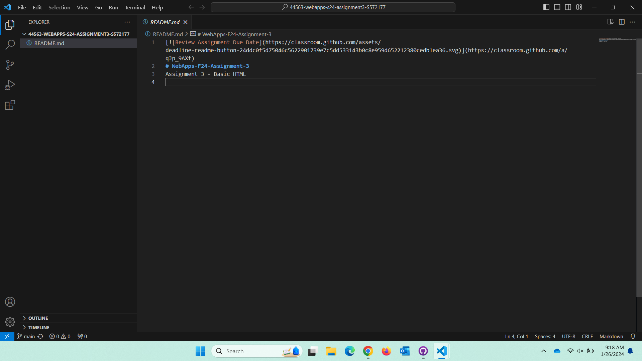

Screen shot2 on your browser of rendered page and the inspector

